Project Design Phase-II
Data Flow Diagram & User Stories

Date | 19 February 2026
Team ID | LTVIP2026TMIDS46852
Project Name | Importing & Securing Data in ServiceNow
Maximum Marks | 4 Marks

Data Flow Diagrams:
A Data Flow Diagram (DFD) is a traditional visual representation of the information flows within a system. A neat and clear DFD can depict the right amount of the system requirement graphically. It shows how data enters and leaves the system, what changes the information, and where data is stored.
DFD Level 0 (Industry Standard)
External Data Source (CSV/Excel) → ServiceNow System → Reports/Dashboard
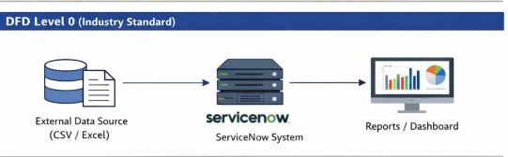
Explanation:
1. External HR/Business systems provide employee-related data.
2. Data is imported into ServiceNow.
3. Processed data is used for reporting and dashboards.

DFD Level 1 (Simplified)
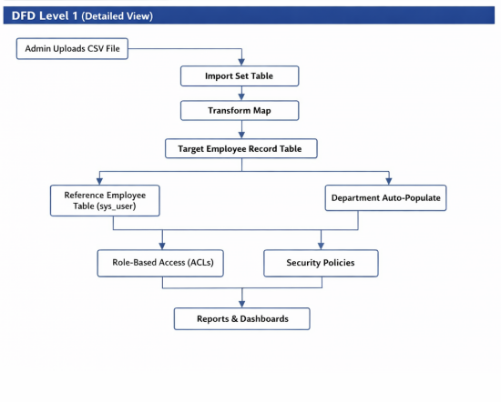
1. Admin uploads CSV File.
2. Data stored in Import Set Table.
3. Transform Map processes the data.
4. Records inserted into Target Custom Table.
5. Employee reference linked to sys_user table.
6. Department auto-populated from employee record.
7. Access Control Rules (ACL) enforce security.
8. Managers generate department-wise reports.

User Stories

User Type | Functional Requirement (Epic) | User Story Number | User Story / Task | Acceptance criteria | Priority | Release
Administrator | Data Import | USN-1 | As an Admin, I can upload a CSV file into ServiceNow. | Data successfully loaded into Import Set Table. | High | Sprint-1
Administrator | Data transformation | USN-2 | As an Admin, I can run Transform Map to move data to target table. | Records inserted without errors. | High | Sprint-1
HR | Employee Validation | USN-3 | As HR, I can verify department auto-population. | Department matches employee record in sys_user table. | High | Sprint-1
Manager | Reporting | USN-4 | As a Manager, I can filter records by department. | System displays department-wise records. | High | Sprint-1
Manager | Reporting | USN-5 | As a Manager, I can generate and export reports. | Report generated and downloadable in Excel format. | Medium | Sprint-2
Employee | Record Access | USN-6 | View linked records  Restricted field editing | Only own records visible  Unauthorized edits prevented | High | Sprint-1

